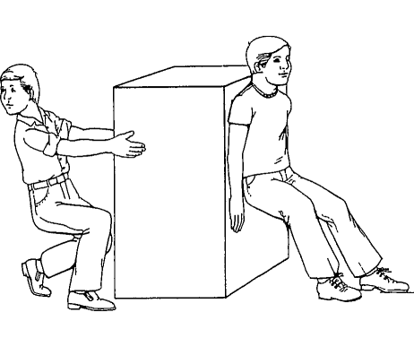
Pushing and Pulling are Kinds of Forces
Pushing or pulling forces can be used to change the motion of an object. When force is
applied, the object can start moving, stop moving, change speed, or change direction.

Effect of Force Strength on Motion
The motion of an object acted on by a force depends partly on the strength of the push
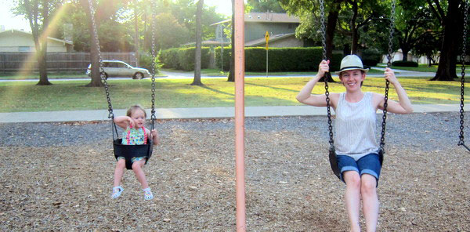
or pull. The stronger the push or pull, the faster the object will move. For example, how does force affect the people on the swing below?

Effect of Object Mass on Motion
The motion of an object acted on by a force also depends on the mass of the object. If the same amount of force is used to move two objects with different masses, the object with less mass will move faster.
For example, if both children were pushed with the same amount of force, what would happen?

How does mass affect force?

Gravity
Gravity is a force that acts on an object without having to touch it. Gravity pulls downward on
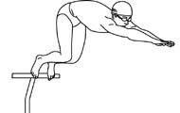
everything that is on or near the Earth's surface.
The Earth's gravity pulls everything on Earth (or near the Earth) down toward the center
of the Earth. Gravity is able to act on things, even if the things aren't touching the Earth's surface.

Gravity pulls everything that falls, such as fruit from a tree or a diver jumping from a
diving board, toward the center of the Earth.

What happens when this diver jumps from the diving board? Why?

When an object is lifted up, the force of gravity must be overcome. A person hanging from the monkey bars works against gravity to hold himself up. Very heavy things are harder to lift or move because the force of gravity is stronger for objects with more mass.

Friction
Friction is a force that opposes motion when two objects are touching one another.
Friction is a force that opposes motion, which means it causes a moving object to slow
down or stop. Friction can also prevent an object at rest from moving.
How is friction affecting this soccer ball? What is the friction?
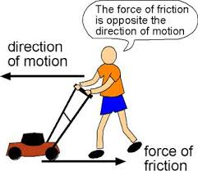
For instance, friction is the force that keeps a lawn mower from sliding across the ground
when it is pushed. If a person is pushing on a lawn mower to move it, friction acts on it in the
opposite direction of the pushing force. If the lawn mower starts to move, then the force of
pushing is stronger than the force of friction.

Friction can be reduced by smoothing the surfaces of the objects in contact with each
other. For example, putting wax on skis reduces the force of friction between the skis
and the snow. Pouring water onto a slide reduces the friction between a person and the
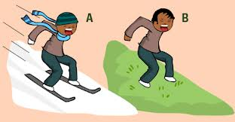
slide, allowing the person to slide down more quickly.

Describe how friction is affecting this boy in each scenario:

Object Motion
If an object is moving in a way that changes its position, then the object is in motion. Motion is a
change in position relative to a frame of reference.
Position & Motion
When we talk about an object's position, we can describe it relative to a reference point. All that means is if we know where one thing is, we can tell someone where something else is relative to, or compared to, the first thing.
If an object is moving in a way that changes its position, then the object is in motion. Motion is a change in position relative to a frame of reference.
The position of an object that is in motion is always changing. It does not stay in the same place. The direction that an object is moving might change or it might stay the same.

Describe the position of the objects below (in relation to the other objects- “the man is to the left of the tree”):
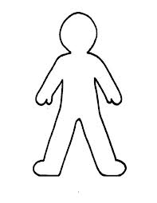
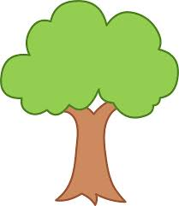
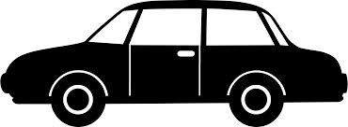

Now describe which objects are in motion. How do you know?

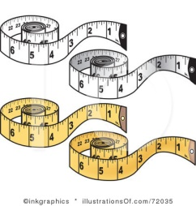
Direction
Direction is the path along which something is moving.
Words that can be used to describe the direction of an object's movement include:
up or down
left or right
north, south, east, or west
Distance is the length between two positions or locations. Distance can be measured in meters, yards, inches, or centimeters with rulers, measuring tapes, or meter sticks. Longer distances can be measured in kilometers or miles.

Speed
Speed is a measurement of how fast an object moves. Faster objects move farther than slower objects if both objects move the same amount of time.
To calculate speed, you find the distance traveled within a given time:
speed = total distance traveled / total travel time

For example, if a car traveled 200 kilometers in 2 hours, the car's speed would be
200 km / 2 hrs = 100 km/hr

What is the speed of a man who ran 10 miles in 2 hours?

Graphing Motion
Lines on distance-time graphs represent speed. If the line is completely horizontal, the slope of the line
and the speed are zero. This means object is standing still.

If the line has a positive slope, the speed is positive. The object is moving away from its origin.

If the line is straight, the object has a constant positive speed.
If the line is curved, the object has a changing, positive speed.
If a graph shows that an object is in motion, then the slope will tell you how fast the object is moving. The steeper the slope, the greater the speed.

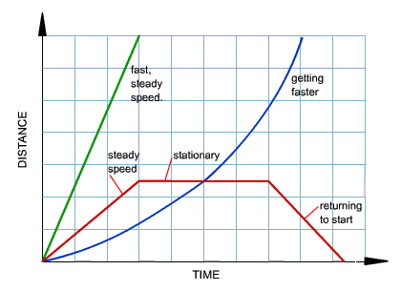
The coordinates at any point on a distance-time graph tell the object's position at the corresponding time.

